**Full Job Description** 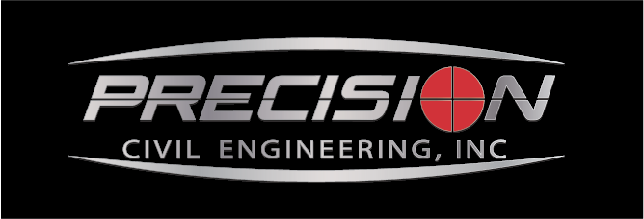

**JOB TITLE: Senior Planner**   
**LOCATION: Fresno, CA**

Precision Civil Engineering, Inc. (PCE) is looking for a highly motivated Senior Planner who can hit the ground running. We have both private and public agency clients which allows for opportunities for growth and keeps the work interesting and exciting. We are a small but growing planning division that needs assistance from an experienced Planner to keep things growing. Come join us and experience a laid-back, but hard-working team of professionals who make it a priority to serve our clients and empower our staff.

**Job Responsibilities:**

* Performs advanced professional work related to variety of planning assignments.
* Manages complex planning studies, development applications and projects.
* Manages private development projects through the entitlement process and advocates on clients' behalf.
* Reviews and processes and prepares complex comprehensive plan amendments, rezonings, annexations, site plans.
* Prepares and reviews environmental documents in compliance with the California Environmental Quality Act (CEQA).
* Develops project budgets, administers bidding process, verifies contract expenditures and compliance.
* Assists with the review and preparation of RFPs and RFQs
* Conducts research and prepares statistical reports on land use, physical, social & economic issues.
* Provides professional planning assistance to communities on varied land use projects.
* Develops transportation plans, studies, and analyses on regional basis.
* Presents reports and other findings to staff, planning and zoning boards and commissions, and elected officials.
* Attends occasional evening meeting as needed.
* Supervises more junior planners within organization.

**Qualifications & Experience:**

**Preferred Qualifications:**

* 3 or more years' relevant experience in either the public or private sector.
* Environmental and land use planning experience.
* Advanced knowledge of the philosophies, principals, practices & techniques of planning.
* Knowledge of principles, methodology, practices of research and data collection.
* Knowledge of effective writing techniques.
* Knowledge of computer programs and applications, which may include Microsoft Office, Internet applications, Adobe etc.
* GIS programs and applications.

**Key Attributes:**

* Excellent oral and written communication skills for preparing and presenting planning reports and projects.
* Excellent interpersonal skills for facilitating relationships with elected/appointed officials or other decision-makers.
* Creative problem-solving skills to gather relevant information to solve less well- defined planning problems.
* Group facilitation skills for use with community workshops.
* Ability to work on several projects or issues simultaneously.
* Ability to provide effective supervision and staff management.
* Ability to manage projects effectively and meet firm deadlines.
* Ability to facilitate in-person and virtual public participation activities.

**Education:**

* Bachelors in Urban Planning, Geography, Political Science, Architecture, Real Estate, or related field. Master’s degree preferred but not required.
* Master’s degree and/or AICP certification preferred but not required.

**Work Location:** Fresno, CA

**Job Type:** Full-time

**Benefits:**

* Paid time off.
* Medical, dental & vision insurance.
* Life insurance and disability benefits.
* Generous 401(k) + matching.
* Onsite gym.
* Quarterly and annual company events.

**Schedule:**

* 8-hour shift
* Monday to Friday